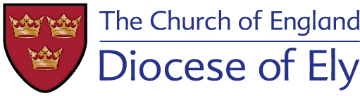
IME- 2 Training Officer
Revd Steve Rothwell

Email: steven.rothwell@elydiocese.org

IME2 Formational Training and Assessment Plan 2021/22

During your curacy we aim to provide you with an overall discernment process for the first years in ordained ministry to help point the way forward for future ministry.

The training will provide you with a peer group within which to explore the experiences of ministry; provide you with skills necessary to grow into the public ministry if a priest and to continue to develop and flourish in this changing role.

IME2 is not an optional extra, but a core aspect of your curacy. You are expected to make attendance at IME2 days and tutor groups a priority.

The morning sessions usually start promptly at 10am and finish by 1pm, this includes time to network with colleagues. Evening session usually run from 7pm to 9pm.

